The Quest for Sapo

Felipe Simas

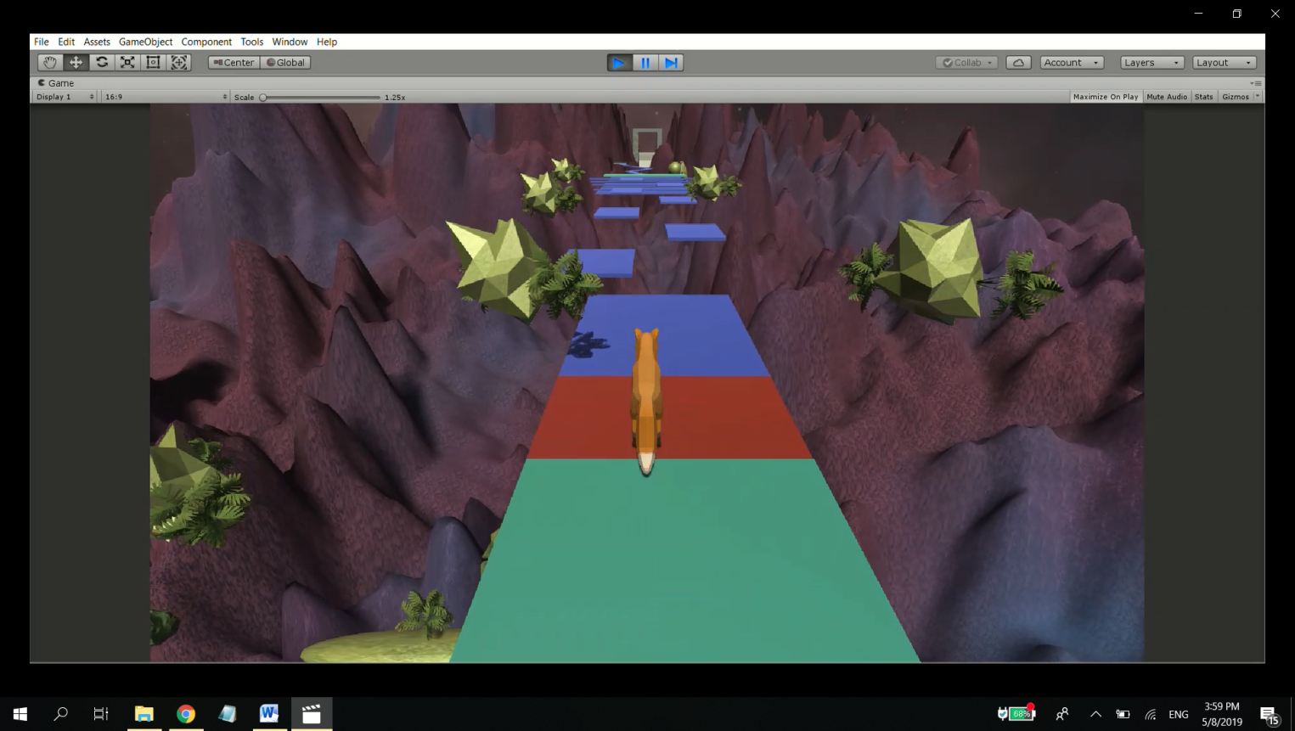This third-person platforming game takes the player on a journey through a mysterious land in outer space. You play as a fox tasked with restoring nature to this land in order to meet the mystical giant frog spirit.

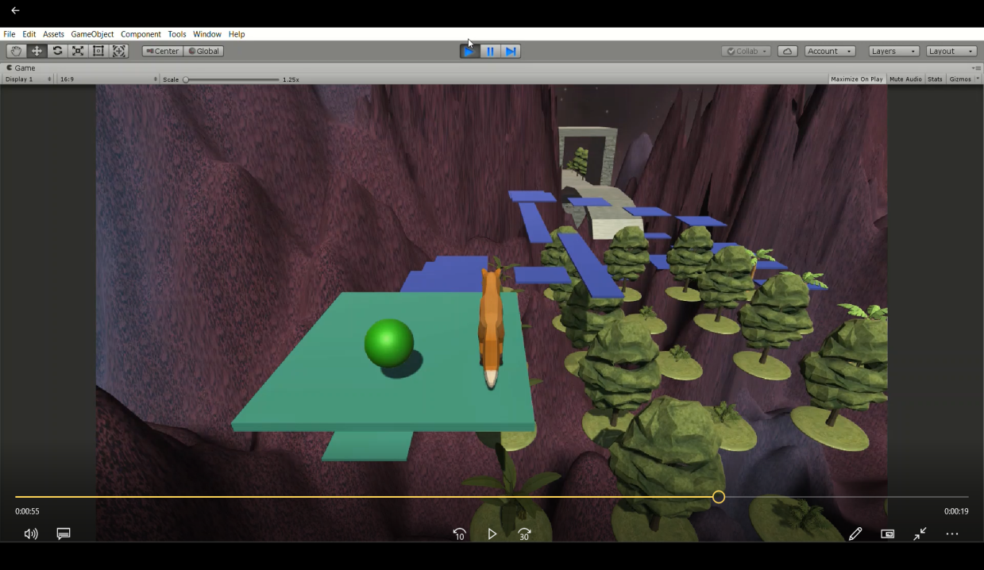Features:

Falling platforms;

Plants and trees growing through triggered animations after reaching certain points or activating buttons.

Special thanks to Mike Treanor and Andrew Yim for their help.